Session 6 -1
class Solution {
public int[] buildArray(int[] nums) {
// Create a new array of the same length
int[] ans = new int[nums.length];

// Fill the array using the given logic
for (int i = 0; i < nums.length; i++) {
ans[i] = nums[nums[i]];
}

return ans;
}
}
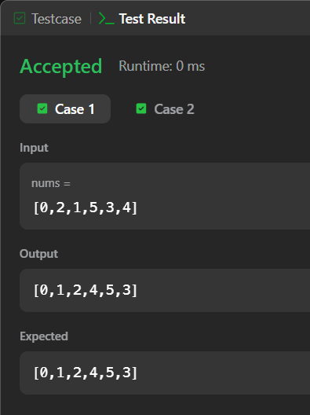

Session 6 -2
class Solution {
public int[] shuffle(int[] nums, int n) {

int[] result = new int[2 * n];

for (int i = 0; i < n; i++) {
result[2 * i] = nums[i];
result[2 * i + 1] = nums[i + n];
}
return result;
}
